**Assignment 08**

**QUESTIONS:**

**1. a. Suppose a network exchange theory experiment is run on the graph to the right using the one-exchange rule. Which node or nodes you would expect to make the most money? (i.e. receive the most favorable exchanges)**

**b. Explain your answer**

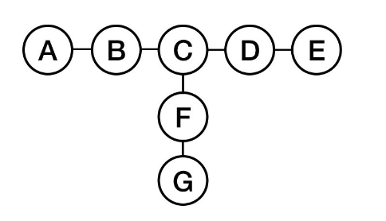

**Answer:**

Although node C seems to be powerful, I would expect nodes B, D and F to make the most money because node C is connected to other three nodes B, D and F, but each of which has an attractive alternative. Thus, C can be excluded as easily as nodes A, G or E. This weaken node C in this experiment.

**2. a. Suppose a network exchange theory experiment is run on the graph to the right (i.e. a graph that is a 3-node path), using the one-exchange rule. Now you, playing the role of a fourth node d, are told to attach by a single edge to one of the nodes in the network. How should you attach to the network to put yourself in as powerful a position as possible, where power will be determined by the result of a network exchange theory experiment run on the resulting 4-node network?**

**b. Explain your answer**



**Answer:**

I should attach the fourth node D to either node A or node C to put myself in as powerful position as possible. Because if I will connect to node B, the chances that B will exchange with me is very less as B is connecting to other two nodes also. So, better to connect with end nodes that raises the probability that end nodes will exchange with me as they also think that node B has other choices.

**3.The graphs below represent the outcomes of a network exchange theory experiment. For each, determine whether the outcome is stable or unstable, and explain your answer.**

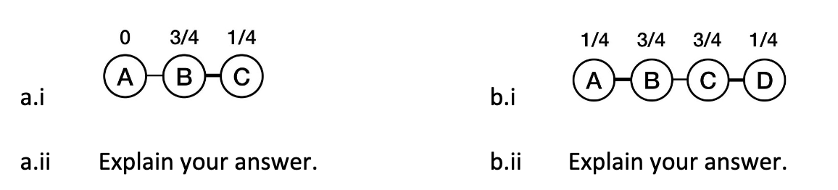

**Answer:**

**(a)** The outcome of graph (a) is **unstable** because A + B < 1; A can offer a better split to B (e.g. 1/8 A, 7/8 B) and both do better.

**(b)** The outcome of graph (b) is **stable** because neither node B nor C can offer or get anything from each and other better from what they have now.

**4. The stem graph below represents the outcome of a network exchange theory experiment in which the participants have outside options. In this experiment, A bargained with B and C bargained with D. Use the Nash Bargaining Solution equations to show that this is a balanced outcome. Show your work.**

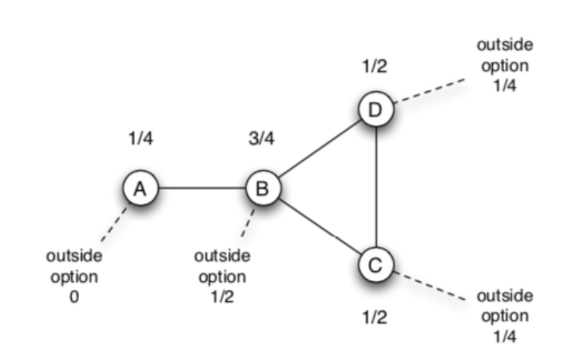

**Answer:**

Let’s derive Nash Bargaining Solution for A,B.

Here, S = 1 – (0 + ½ ) = ½

So, for A, outside option is 0 +(½)/2 = ¼

And for B, outside option is ½ + ¼ = ¾

**Nash Bargaining Solution**: **¼ and ¾**

Thus, we can say that the network is balanced for A and B

Now, let’s derive Nash Bargaining Solution for C,D.

Here, S = 1 – ( ¼ + ¼ ) = ½

So, for C, outside option is ¼ + ¼ = ½

And for D, outside option is ¼ + ¼ = ½

**Nash Bargaining Solution: ½ and ½**

We can see from the above Nash Bargaining Solutions, none of the nodes in the network has strong or better outside options. So, we can say that the given stem graph is balanced.

**5.Your company has decided to interview two candidates A and B for a single job. A hiring committee was formed to decide which of the two candidates to hire. Everyone on the committee was interested in making the best possible hire, but after the interviews it was clear that members of the committee had different ideas about which of the two candidates was the best choice. When the committee met to make the final decision they decided to go around the room and ask each person on the committee to announce which of the two candidates they believed to be the best choice for the company. In fact, everyone on the committee said that candidate A seemed to be the best choice, so the offer was made immediately to candidate A without additional discussion. Now that candidate A has worked for the firm for a while it is clear that candidate B would have been a better choice.**

**a. Your boss has asked you to explain how the committee members could have unanimously supported candidate A when she was reasonably certain that before the committee meeting at least some of the members of the committee thought that B was probably the best choice. Based on the teachings of chapter 16, what can you tell here?**

**b. Can you suggest another procedure that the committee could have used that would have revealed the initially differing opinions about the candidates and which might have avoided the unanimous choice of candidate A and resulted in the actually better choice of candidate B?**

**Answer:**

**(a)** One reason behind why the committee members could have unanimously opt to hire candidate A is information cascade. Because while making the final decision, boss asks each person to announce the best candidate for the company that they believed. In this case, it may happen that first two persons announce that candidate A is the best choice according to them and later because other people aware about previous decision, even if they think candidate B is best, they changed their decision and announce that candidate A is the best.

**(b)** In my opinion, there can be one simple strategy that all committee members give vote without knowing about other’s decision and then based on major votes, candidate will be chosen and considered to be the best for the company.

Moreover, according to me, hiring procedure must have some standard methods or parameters defined, basis on which candidate should be chosen. As illustration, some of the parameters such as domain knowledge, qualification, culture fitment, leadership, experience, work ethics, team building etc. needed to be considered into account. And all committee members must measure all these parameters independently in a percentage/ ratio that can be really helpful in taking such hiring decision right and accurate. If the committee has adopted this strategy, they can find that candidate B is overall a great fit by taking average of all individual measured parameters.

**6. You have developed a new product which performs the same service as an established product, but your product is much better than the established product. If the number of users of the two products were the same, then each potential purchaser’s reservation price for your product would be twice their reservation price for the existing product. The difficulty that you face is that no one wants to use more than one of the two products. Currently, every potential purchaser is using the established product. Your cost of production and your competitor’s costs of production are exactly the same and they are equal to the price at which your competitor’s product is sold. If all of the potential purchasers switched to your product the maximum price that you could charge (and still have all of them buy your product) would be twice the current price. So clearly you could make a nice profit if you could attract these potential purchasers. Based on the teachings of Chapter 17, what strategies would you use to try to convince users to switch to your product?**

**Answer:**

In given situations, I should come up with some good strategies so that I can attract the potential purchasers and sell my new product to them. One of the strategies that I would use is introducing my product with lower price than the established product. Although the cost of production is same for both products, I will lower the price, otherwise none of the users will even try or switch to my product because the established product is quite popular in the market and people are used to use that products.

After I lower the price of my new product, not all but definitely some of the purchasers are going to purchase it and because my product is quite better than the established one, they will continue to purchase it and also refer to their friends, relatives or collogues to use that. And I will also try to provide after-sell services to allure more users.

Furthermore, though I lower the price, it might be the case that all purchasers are not aware about my new product. So, advertisements are essential part to promote my product. Now, the way we choose to advertise is also very important. I will first identify the fashion leaders or very famous people whose adoption of the product will attract others to follow the same. I can opt them not only for advertising purpose, but also I will try to sell my product to them, which can be helpful in making my product more popular among the people and later the established one.

After I applied above strategies, I am definitely going to make a nice profit, because I could make my product sell twice than the cost because of users’ willingness to pay i.e. reservation price.

**7. Consider an on-line news site, such as cnn.com, which consists of a front page with links to many different articles. The operators of these sites generally track the popularity of the various articles that get posted. Suppose that the operators of the site are considering changing the front page, so that next to each link is a counter showing how many people have clicked on the link. (e.g., next to each link it might say: “30,480 people have viewed this story,” with the number getting updated over time.)**

**a. What effect do you think this change will have on the behavior of people using the site?**

**b. Do you expect that adding this feature will cause the popularity distribution of the articles to follow a power-law distribution more closely or less closely, compared to the version of the site before these counters were added?**

**c. Explain your answer.**

**Answer:**

**(a)** Initially, a front page of an on-line news website consists of various links to many different articles, but now, the operator tracks the popularity of the site and displaying number of viewers besides the link. In this case, people will prefer to open the links that have a greater number of viewers compared to the links that have lesser number of viewers.

In my opinion, the popular links will be viewed more and more and they will become more popular same as we have studied in Richer-Get-Rich effect.

**(b)** I do definitely expect that adding this new feature will cause the popularity distribution of the articles to follow a power-law distribution more closely compared to the previous version without having total number of viewers of each link

**(c)** As illustration, I do generally prefer to watch any video or movie on YouTube by considering total number of views. And on Google also, as we are familiar with the fact that the articles are arranged in a way of popularity and relativeness of our search, we do every time prefer to open first few links only.

Thus, Even though people will have some specific in their mind for watching the news, when they will come across the major number of viewers for some articles, they do surely visit that link and prefer to read with curiosity to know about it.

**8. Consider the network to the right. Suppose that each node starts with the behavior B, and each node has a threshold of q = 1/2 for switching to behavior A.**

**a. Let e and f form a two-node set S of initial adopters of behavior A. If other nodes follow the threshold rule for choosing behaviors, which nodes will eventually switch to A?**

**b. Find a cluster of density greater than 1 -q= 1/2 in the part of the graph outside S that blocks behavior A from spreading to all nodes, starting from S, at threshold q.**

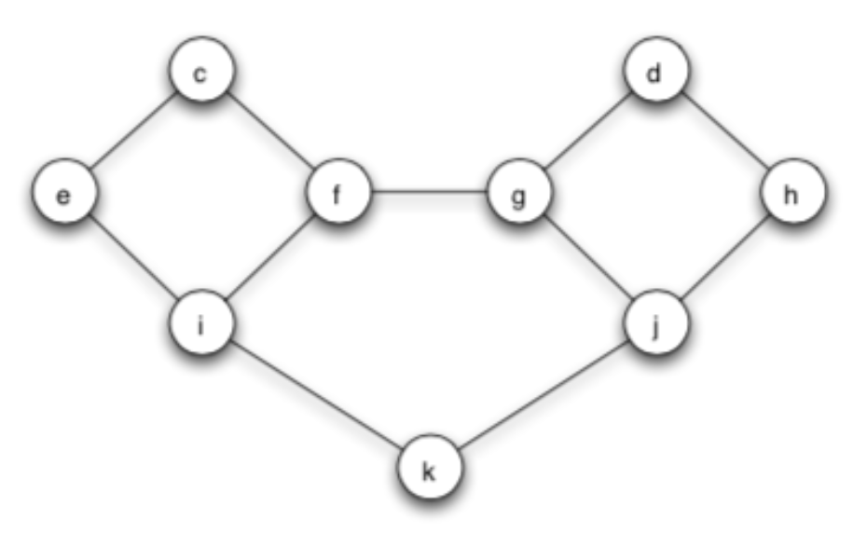

**Answer:**

**(a)** Here, each node has a threshold q= ½ for switching to behavior A and e and f are initial adopters of behavior A. If other nodes follow the threshold rule for choosing behaviors, in first step, nodes c, i will eventually switch to A

**Step 1:**

For nodes c, i the fraction of neighbors choosing A are 2/2 and 2/3 respectively >= q 🡪 They switch

For nodes g, the fraction of neighbors choosing A is 1/3 = 0.33 q 🡪 It doesn’t switch

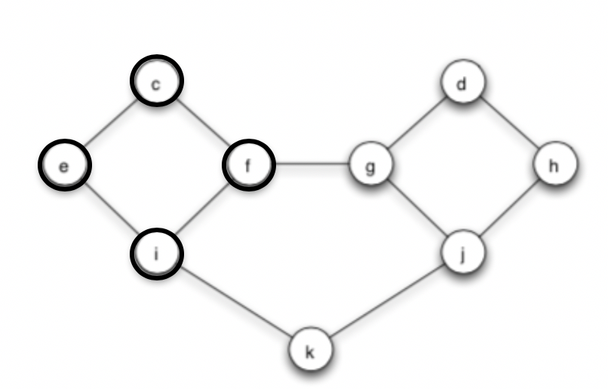

**Step 2:**

For node k, the fraction of neighbors choosing A is 1/2 q 🡪 It switches

For nodes g, j the fraction of neighbors choosing A is 1/3 q 🡪 They don’t switch

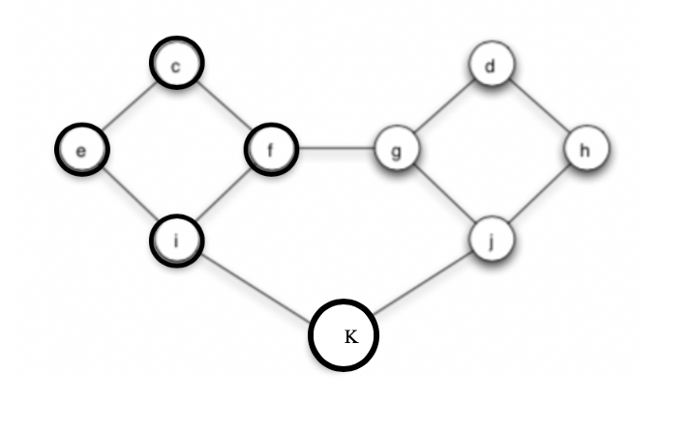

The diffusion stops here. No more nodes willing to switch.

**(b)** Below figure shows a cluster in dotted circle line that of density greater than 1 - q = 1/2 outside S that blocks behavior A from spreading to all nodes, starting from S, at threshold q.

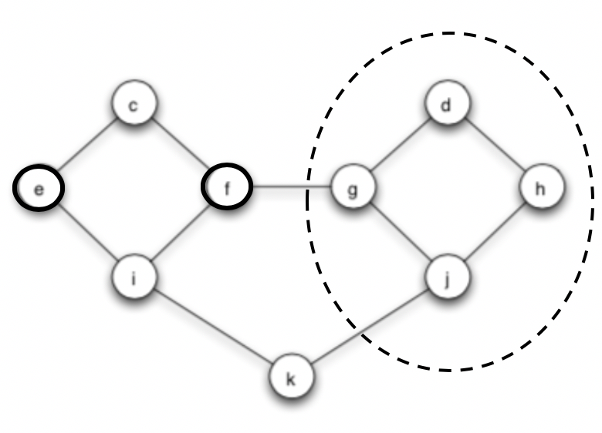

Cluster of Density = 2/3

**9. Using several sentences, in general terms, in your own words, explain the effect that a tightly-knit community can have on a cascade.**

Tightly-knit community can sometimes act as a barrier to diffusion and can stop cascading. Because in tightly-knit community, people are connected with others who are like themselves and they tend to interact with those people only.

We are aware of the fact that most of the new innovations tend to arrive from outside the system and it would be difficult for these innovations to make their way to enter into a tightly-knit community.

As illustration, observe the figure of (b) part of above question 8. In that, because of the tightly-knit network showed on right side as dotted line, cascading of following behavior A stops to spread further from S in the entire network.

Thus, homophily can often serve as a barrier to diffusion, by making it hard for innovations to arrive from outside densely connected communities.